Mathematics Curriculum Intent
At Villiers Primary School, our inclusive maths curriculum encourages all children to have a resilient, collaborative attitude towards the subject of mathematics. Through our ‘can-do’ approach, children are encouraged to become independent thinkers who are confident and excited to take on engaging and thought-provoking challenges within their maths lessons. Mathematics is integral to all aspects of life and with this in mind we endeavour to ensure that children develop a positive and enthusiastic attitude towards mathematics that will stay with them throughout their education. With this in mind, we are assessing the impact COVID-19 has had on children’s progress and are promoting a rapid catch-up from lost learning through giving children opportunities to complete workbooks at home to embed lessons taught in class.
As a school, we follow the White Rose Maths Hub scheme of learning which provides the children with the skills to become fluent in the fundamentals of mathematics, giving daily opportunities to problem solve and reason mathematically in a range of real-life contexts. Teachers plan a systematic build-up of fluency, problem solving and reasoning tasks within lessons to encourage focused and meaningful discussions to further enrich understanding. White Rose Maths Hub has also adapted its schemes of learning to ensure that any lost learning due to COVID-19 has been addressed within each block of work.
We aim to provide the pupils with a mathematics curriculum and high quality teaching to produce individuals who are numerate, creative, independent, inquisitive, enquiring and confident. We also strive to provide a stimulating environment and adequate resources so that pupils can develop their mathematical skills to the full.
Alongside White Rose Maths Hubs, we use the National Curriculum mathematics program of study (2014) to ensure that we have full curriculum coverage and strong progression throughout school from Early Years to Year 6. These are outlined in more detail below:

Early Years Curriculum

In Early Years, Mathematics involves developing the necessary skills to excel mathematically and become confident in: counting; developing a deep understanding in numbers to 10 and understanding the relationships and patterns within those numbers; calculating simple addition and subtraction problems; and developing their spatial reasoning skills through working with shapes, spaces, and measure. Children are exposed to a range of manipulatives to build and apply their understanding and develop their mathematical vocabulary. Our aim is to develop all children’s positive attitudes towards mathematics and not be afraid to make mistakes.

Pupils are taught to:

Number
- Have a deep understanding of number to 10, including the composition of each number;
- Subitise (recognise quantities without counting) up to 5;
- Automatically recall (without reference to rhymes, counting or other aids) number bonds up to 5 (including subtraction facts) and some number bonds to 10, including double facts.

Numerical Patterns
- Verbally count beyond 20, recognising the pattern of the counting system;
- Compare quantities up to 10 in different contexts, recognising when one quantity is greater than, less than or the same as the other quantity;
- Explore and represent patterns within numbers up to 10, including evens and odds, double facts and how quantities can be distributed equally.
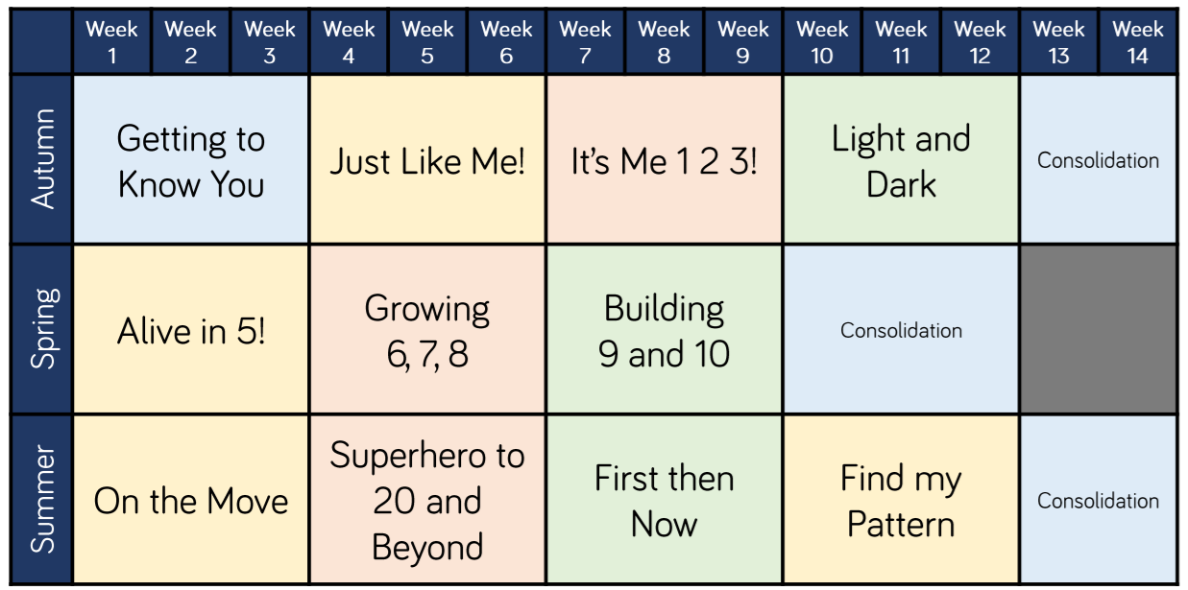

Key Stage 1

The National Curriculum (2014) states that:

The principal focus of mathematics teaching in key stage 1 is to ensure that:

- pupils develop confidence and mental fluency with whole numbers, counting and place value
- this involves working with numerals, words and the four operations, including with practical resources [for example, concrete objects and measuring tools].
- pupils should develop their ability to recognise, describe, draw, compare and sort different shapes and use the related vocabulary
- teaching should also involve using a range of measures to describe and compare different quantities such as length, mass, capacity/volume, time and money

By the end of year 2 pupils should know the number bonds to 20 and be precise in using and understanding place value. An emphasis on practice at this early stage will aid fluency.

Pupils should read and spell mathematical vocabulary, at a level consistent with their increasing word reading and spelling knowledge at key stage 1.

Year 1 Yearly Overview and NC Objectives

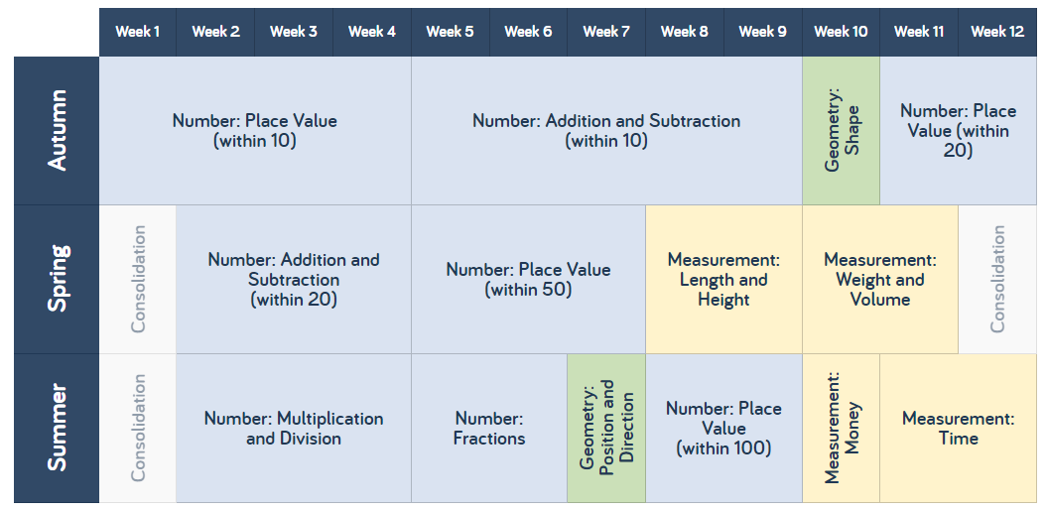
Numbers and the number System
- count to and across 100, forwards and backwards
- count, read and write numbers to 100 in numerals
- count in multiples of twos, fives and tens
- identify one more and one less
- identify and present numbers using objects and pictorial representations including a number line
- use language of: more than, less than (fewer), most, least, equal to
- read and write numbers from 1 to 20 in numerals and words
Fractions and Decimals
- recognise, find and name a half as one of two equal parts of an object, shape or quantity
- recognise, find and name a quarter as one of four equal parts of an object, shape or quantity
Addition and Subtraction
- read and write mathematical statements involving addition +, subtraction – and equals = signs
- use number bonds and related subtraction facts within 20
- add and subtract one digit and two digit numbers to 20, including zero
- solve one step problems, suing concrete and pictorial representations, including missing number problems
Multiplication and Division
- solve one step problems involving multiplication and division
- using concrete objects, pictorial representations and arrays with support from the teacher
Geometry
- recognise and name common 2-D shapes: rectangles, squares, circles and triangles
- recognise and name common 3-D shapes: cuboids, cubes, pyramids and spheres
Measurement
- solve practical problems for:

- lengths/heights (long/short, longer/shorter, tall/short, double/half)
- mass/weight (heavy/light, heavier than, lighter than)
- capacity and volume (full/empty, more than, less than, half, half full, quarter)
- time (quicker, slower, earlier, later)
- measure and being to record lengths, heights, mass/weight, capacity, volume and time hours, minutes, seconds)
- recognise and know the value of different coins and notes
- sequence events in chronological order using language like: before, after, next, first, today, yesterday, tomorrow, morning, afternoon and evening
- use language related to dates, including days of the week, weeks, months and years
- tell the time to the hour and half past the hour and draw hands on a clock face to show these

Year 2 Yearly Overview and NC Objectives

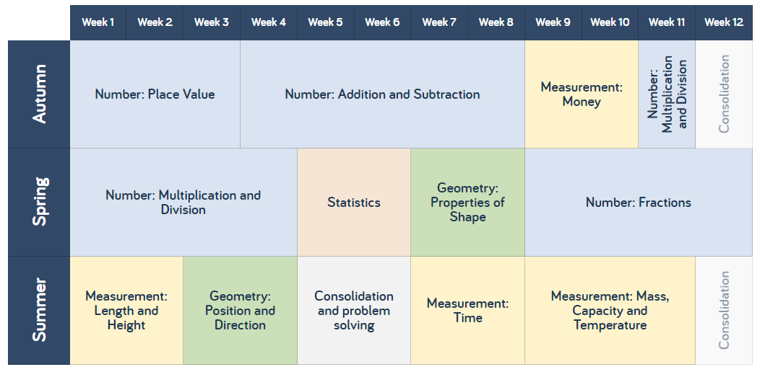
Numbers and the Number System
- count in steps of 2, 3, and 5 from 0, and in tens from any number, forward and backward
- recognise the place value of each digit in a two-digit number (tens, ones)
- identify, represent and estimate numbers using different representations, including the number line
- compare and order numbers from 0 up to 100; use > < and = signs
- read and write numbers to at least 100 in numerals and in words
- use place value and number facts to solve problems.
Fractions and Decimals
- recognise, find, name and write fractions 1/3, ¼, 2/4,and ¾ of a length, shape, set of objects or quantity
- write simple fractions; ½ of 6 = 3 and recognise equivalence of 2/4 and ½
Addition and Subtraction
- solve problems with addition and subtraction: including those involving numbers, quantities and measures
- recall and use addition and subtraction facts to 20 fluently, use related facts up to 100
- add and subtract numbers using concrete objects, pictorial representations, and mentally, including: a two-digit number and ones, a two-digit number and tens, two two-digit numbers, adding three one-digit numbers
- show that addition of two numbers can be done in any order (commutative) and subtraction cannot
- use the inverse relationship between addition and subtraction to check calculations and solve missing number problems
Multiplication and Division
- recall and use multiplication and division facts for the 2, 5 and 10 multiplication tables
- recognising odd and even numbers
- calculate mathematical statements for multiplication and division within the multiplication tables and write them using the multiplication (×), division (÷) and equals (=) signs
- show that multiplication of two numbers can be done in any order (commutative) and division cannot
- solve problems involving multiplication and division, using materials, arrays, repeated addition, mental methods, and multiplication and division facts, including problems in context
Geometry
- identify and describe the properties of 2-D shapes; number of sides and line symmetry in a vertical line
- identify and describe the properties of 3-D shapes; number of edges, vertices and faces
- identify 2-D shapes on the surface of 3-D shapes, [a circle on a cylinder and a triangle on a pyramid]
- compare and sort common 2-D and 3-D shapes and everyday objects
- order and arrange combinations of mathematical objects in patterns and sequences
- use mathematical vocabulary to describe position, direction and movement, including movement in a straight line and distinguishing between rotation as a turn and in terms of right angles for quarter, half and three-quarter turns (clockwise and anti-clockwise)
Measurement
- choose and use appropriate standard units to estimate and measure length/height in any direction (m/cm); mass (kg/g); temperature (°C); capacity (litres/ml) to the nearest appropriate unit
- compare and order lengths, mass, volume/capacity and record the results using >, < and =
- recognise and use symbols for pounds (£) and pence (p); combine amounts to make a particular value
- find different combinations of coins that equal the same amounts of money
- solve simple problems in a practical context involving addition and subtraction of money of the same unit, including giving change
- compare and sequence intervals of time
- tell and write the time to five minutes, including quarter past/to the hour and draw the hands on a clock face to show these times
- know the number of minutes in an hour and the number of hours in a day
Statistics
- interpret and construct simple pictograms, tally charts, block diagrams and simple tables
- ask and answer simple questions by counting the number of objects in each category and sorting the categories by quantity
- ask and answer questions about totalling and comparing data

Lower Key Stage 2

The National Curriculum (2014) states that:

The principal focus of mathematics teaching in lower key stage 2 is to ensure that:
- pupils become increasingly fluent with whole numbers and the four operations, including number facts and the concept of place value.
- pupils develop efficient written and mental methods and perform calculations accurately with increasingly large whole numbers.
- pupils should develop their ability to solve a range of problems, including with simple fractions and decimal place value.
- pupils draw with increasing accuracy and develop mathematical reasoning so they can analyse shapes and their properties, and confidently describe the relationships between them.
- they can use measuring instruments with accuracy and make connections between measure and number.

By the end of year 4 pupils should have memorised their multiplication tables up to and including the 12-multiplication table and show precision and fluency in their work.

Pupils should read and spell mathematical vocabulary correctly and confidently, using their growing word reading knowledge and their knowledge of spelling.

Year 3 Yearly Overview and NC Objectives
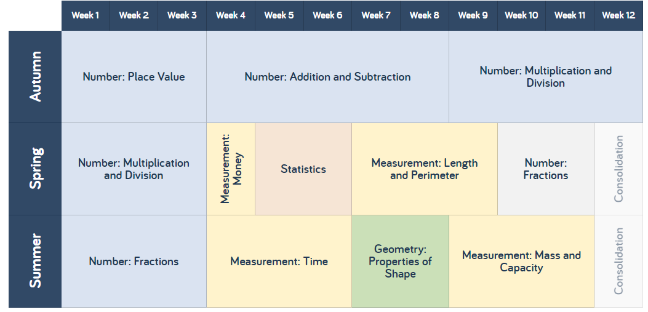

Numbers and the Number System
- count from 0 in multiples of 4, 8, 50 and 100
- find 10 or 100 more or less than a given number
- recognise the place value of each digit in a three-digit number (hundreds, tens, ones)
- compare and order numbers up to 1000
- identify, represent and estimate numbers using different representations
- read and write numbers up to 1000 in numerals and in words
- solve number problems and practical problems involving these ideas
Fractions and Decimals
- count up and down in tenths; recognise that tenths arise from dividing an object into 10 equal parts and in dividing one-digit numbers or quantities by 10
- recognise, find and write fractions of a discrete set of objects: unit fractions and non-unit fractions with small denominators
- recognise and use fractions as numbers: unit fractions and non-unit fractions with small denominators
- recognise and show, using diagrams, equivalent fractions with small denominators
- add and subtract fractions with the same denominator within one whole
- compare and order unit fractions, and fractions with the same denominators
- Solve problems that involve all of the above.
Addition and Subtraction
- add and subtract numbers mentally, including: a three-digit number and ones, a three-digit number and tens, a three-digit number and hundreds
- add and subtract numbers with up to three digits, using formal written methods of columnar addition and subtraction
- estimate the answer to a calculation and use inverse operations to check answers
- solve problems, including missing number problems, using number facts, place value, and more complex addition and subtraction
Multiplication and Division
- recall and use multiplication and division facts for the 3, 4 and 8 multiplication tables
- write and calculate mathematical statements for multiplication and division using the multiplication tables that they know, including for two-digit numbers times one-digit numbers, using mental and progressing to formal written methods
- solve problems, including missing number problems, involving multiplication and division, including positive integer scaling problems and correspondence problems in which n objects are connected to m objects
Geometry
- draw 2-D shapes and make 3-D shapes using modelling materials; recognise 3-D shapes in different orientations and describe them
- recognise angles as a property of shape or a description of a turn
- identify right angles, recognise that two right angles make a half-turn, three make three quarters of a turn and four a complete turn; identify whether angles are greater than or less than a right angle
- identify horizontal and vertical lines and pairs of perpendicular and parallel lines
Measurement
- measure, compare, add and subtract: lengths (m/cm/mm); mass (kg/g); volume/capacity (l/ml)
- measure the perimeter of simple 2-D shapes
- add and subtract amounts of money to give change, using both £ and p in practical contexts
- tell and write the time from an analogue clock, including using Roman numerals from I to XII, and 12-hour and 24- hour clocks
- estimate and read time with increasing accuracy to the nearest minute; record and compare time in terms of seconds, minutes and hours; use vocabulary such as o’clock, a.m./p.m., morning, afternoon, noon and midnight
- know the number of seconds in a minute and the number of days in each month, year and leap year
- compare durations of events
Statistics
- interpret and present data using bar charts, pictograms and tables
- solve one-step and two-step questions [for example, ‘How many more?’ and ‘How many fewer?’] using information presented in scaled bar charts and pictograms and tables.

Year 4 Yearly Overview and NC Objectives
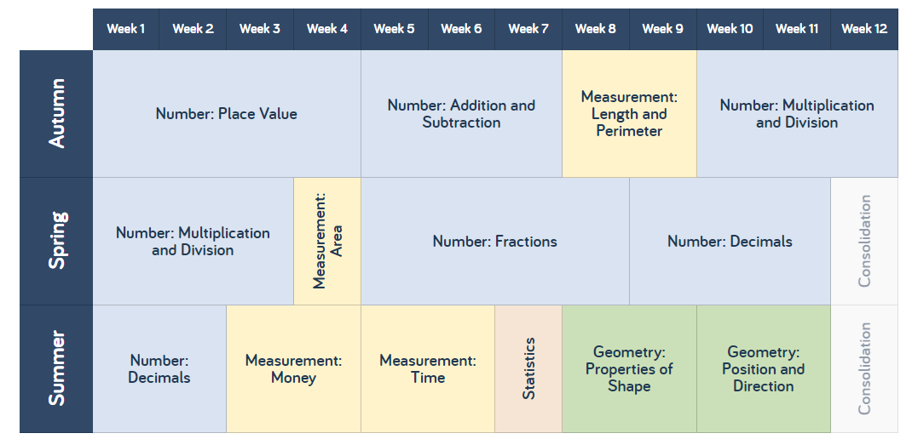
Numbers and the Number System
- count in multiples of 6, 7, 9, 25 and 1000
- find 1000 more or less than a given number
- count backwards through zero to include negative numbers
- recognise the place value of each digit in a four-digit number (thousands, hundreds, tens, and ones)
- order and compare numbers beyond 1000
- identify, represent and estimate numbers using different representations
- round any number to the nearest 10, 100 or 1000
- solve number and practical problems that involve all of the above and with increasingly large positive numbers
- read roman numerals to 100 (I to C) and know that over time, the numeral system changed to include the concept of zero and place value.
Fractions and Decimals
- recognise and show, using diagrams, families of common equivalent fractions
- count up and down in hundredths; recognise that hundredths arise when dividing an object by one hundred and dividing tenths by ten.
- solve problems involving increasingly harder fractions to calculate quantities, and fractions to divide quantities, including non-unit fractions where the answer is a whole number
- add and subtract fractions with the same denominator
- recognise and write decimal equivalents of any number of tenths or hundredths
- recognise and write decimal equivalents
- find the effect of dividing a one- or two-digit number by 10 and 100, identifying the value of the digits in the answer as ones, tenths and hundredths
- round decimals with one decimal place to the nearest whole number
- compare numbers with the same number of decimal places up to two decimal places
- solve simple measure and money problems involving fractions and decimals to two decimal places
Addition and Subtraction
- add and subtract numbers with up to 4 digits using the formal written methods of columnar addition and subtraction where appropriate
- estimate and use inverse operations to check answers to a calculation
- solve addition and subtraction two-step problems in contexts, deciding which operations and methods to use and why.
Multiplication and Division
- recall multiplication and division facts for multiplication tables up to 12 × 12
- multiply two-digit and three-digit numbers by a one-digit number using formal written layout
- solve problems involving multiplying and adding, including using the distributive law to multiply two digit numbers by one digit, integer scaling problems and harder correspondence problems such as n objects are connected to m objects.
Geometry
- compare and classify geometric shapes, including quadrilaterals and triangles, based on their properties and sizes
- identify acute and obtuse angles and compare and order angles up to two right angles by size
- identify lines of symmetry in 2-D shapes presented in different orientations
- complete a simple symmetric figure with respect to a specific line of symmetry.
Position and Direction
- describe positions on a 2-D grid as coordinates in the first quadrant
- describe movements between positions as translations of a given unit to the left/right and up/down
- plot specified points and draw sides to complete a given polygon.
Measurement
- Convert between different units of measure [for example, kilometre to metre; hour to minute]
- measure and calculate the perimeter of a rectilinear figure (including squares) in centimetres and metres
- find the area of rectilinear shapes by counting squares
- estimate, compare and calculate different measures, including money in pounds and pence
- read, write and convert time between analogue and digital 12- and 24-hour clocks
- solve problems involving converting from hours to minutes; minutes to seconds; years to months; weeks to days.
Statistics
- interpret and present discrete and continuous data using appropriate graphical methods, including bar charts and time graphs
- solve comparison, sum and difference problems using information presented in bar charts, pictograms, tables and other graphs.

Upper Key Stage 2

The National Curriculum (2014) states that:

The principal focus of mathematics teaching in upper key stage 2 is to ensure that:
- pupils extend their understanding of the number system and place value to include larger integers.
- this should develop the connections that pupils make between multiplication and division with fractions, decimals, percentages and ratio.
- pupils should develop their ability to solve a wider range of problems, including increasingly complex properties of numbers and arithmetic, and problems demanding efficient written and mental methods of calculation.
- pupils are introduced to the language of algebra as a means for solving a variety of problems.
- teaching in geometry and measures should consolidate and extend knowledge developed in number.
- pupils classify shapes with increasingly complex geometric properties and that they learn the vocabulary they need to describe them.

By the end of year 6, pupils should be fluent in written methods for all four operations, including long multiplication and division, and in working with fractions, decimals and percentages.

Pupils should read, spell and pronounce mathematical vocabulary correctly.

Year 5 Yearly Overview and NC Objectives
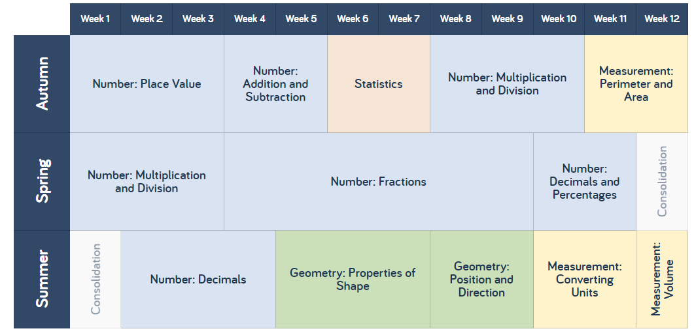
Numbers and the Number System
- read, write, order and compare numbers to at least 1 000 000 and determine the value of each digit
- count forwards or backwards in steps of powers of 10 for any given number up to 1 000 000
- interpret negative numbers in context, count forwards and backwards with positive and negative whole numbers, including through zero
- round any number up to 1 000 000 to the nearest 10, 100, 1000, 10 000 and 100 000
- solve number problems and practical problems that involve all of the above
- read Roman numerals to 1000 (M) and recognise years written in Roman numerals
Fractions and Decimals and Percentages
- compare and order fractions whose denominators are all multiples of the same number
- identify, name and write equivalent fractions of a given fraction, represented visually, including tenths and hundredths
- recognise mixed numbers and improper fractions and convert from one form to the other and write mathematical statements > 1 as a mixed number
- add and subtract fractions with the same denominator and denominators that are multiples of the same number
- multiply proper fractions and mixed numbers by whole numbers, supported by materials and diagrams
- read and write decimal numbers as fractions
- recognise and use thousandths and relate them to tenths, hundredths and decimal equivalents
- round decimals with two decimal places to the nearest whole number and to one decimal place
- read, write, order and compare numbers with up to three decimal places
- solve problems involving number up to three decimal places
- recognise the per cent symbol (%) and understand that per cent relates to ‘number of parts per hundred’, and write percentages as a fraction with denominator 100, and as a decimal
- solve problems which require knowing percentage and decimal equivalents of and those fractions with a denominator of a multiple of 10 or 25
Addition and Subtraction
- add and subtract whole numbers with more than 4 digits, including using formal written methods (columnar addition and subtraction)
- add and subtract numbers mentally with increasingly large numbers
- use rounding to check answers to calculations and determine, in the context of a problem, levels of accuracy
- solve addition and subtraction multi-step problems in contexts, deciding which operations and methods to use and why
Multiplication and Division
- identify multiples and factors, including finding all factor pairs of a number, and common factors of two numbers
- know and use the vocabulary of prime numbers, prime factors and composite (non-prime) numbers
- establish whether a number up to 100 is prime and recall prime numbers up to 19
- multiply numbers up to 4 digits by a one- or two-digit number using a formal written method, including long multiplication for two-digit numbers
- multiply and divide numbers mentally drawing upon known facts
- divide numbers up to 4 digits by a one-digit number using the formal written method of short division and interpret remainders appropriately for the context
- multiply and divide whole numbers and those involving decimals by 10, 100 and 1000
Geometry
- identify 3-D shapes, including cubes and other cuboids, from 2-D representations
- know angles are measured in degrees: estimate and compare acute, obtuse and reflex angles
- draw given angles, and measure them in degrees
- identify angles at a point and one whole turn (total 360)
- angles at a point on a straight line and a turn (total 180)
- other multiples of 90o
- use the properties of rectangles to deduce related facts and find missing lengths and angles
- distinguish between regular and irregular polygons based on reasoning about equal sides and angles
- identify, describe and represent the position of a shape following a reflection or translation, using the appropriate language, and know that the shape has not changed.
Measurement
- convert between different units of metric measure (for example, kilometre and metre; centimetre and metre; centimetre and millimetre; gram and kilogram; litre and millilitre)
- understand and use approximate equivalences between metric units and common imperial units such as inches, pounds and pints
- measure and calculate the perimeter of composite rectilinear shapes in centimetres and metres
- calculate and compare the area of rectangles (including squares), and including using standard units, square centimetres (cm2) and square metres (m2) and estimate the area of irregular shapes
- estimate volume [for example, using 1 cm3 blocks to build cuboids (including cubes)] and capacity [for example, using water]
- solve problems involving converting between units of time
- use all four operations to solve problems involving measure [for example, length, mass, volume, money] using decimal notation, including scaling
Statistics
- solve comparison, sum and difference problems using information presented in a line graph
- complete, read and interpret information in tables, including timetables.

Year 6 Yearly Overview and NC Objectives
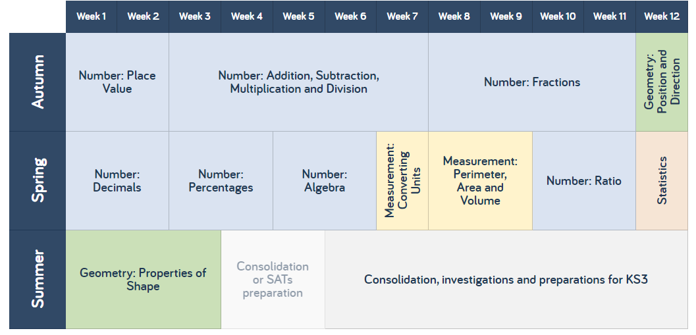
Numbers and Place Value
- read, write, order and compare numbers up to 10 000 000 and determine the value of each digit
- round any whole number to a required degree of accuracy
- use negative numbers in context, and calculate intervals across zero
- solve number and practical problems that involve all of the above
Fractions, Decimals and Percentages
- use common factors to simplify fractions; use common multiples to express fractions in the same denomination
- compare and order fractions, including fractions > 1
- add and subtract fractions with different denominators and mixed numbers, using the concept of equivalent fractions
- multiply simple pairs of proper fractions, writing the answer in its simplest form
- divide proper fractions by whole numbers
- associate a fraction with division and calculate decimal fraction equivalents [for example, 0.375] for a simple fraction
- identify the value of each digit in numbers given to three decimal places and multiply and divide numbers by 10, 100 and 1000 giving answers up to three decimal places
Ratio and proportion
- solve problems involving the relative sizes of two quantities where missing values can be found by using integer multiplication and division facts
- solve problems involving the calculation of percentages [for example, of measures, and such as 15% of 360] and the use of percentages for comparison
- solve problems involving similar shapes where the scale factor is known or can be found
- solve problems involving unequal sharing and grouping using knowledge of fractions and multiples
Algebra
- use simple formulae
- generate and describe linear number sequences
- express missing number problems algebraically
- find pairs of numbers that satisfy an equation with two unknowns
- enumerate possibilities of combinations of two variables
Multiplication, Division, Addition and Subtraction
- multiply multi-digit numbers up to 4 digits by a two-digit whole number using the formal written method of long multiplication
- divide numbers up to 4 digits by a two-digit whole number using the formal written method of long division, and interpret remainders as whole number remainders, fractions, or by rounding, as appropriate for the context
- divide numbers up to 4 digits by a two-digit number using the formal written method of short division where appropriate, interpreting remainders according to the context
- perform mental calculations, including with mixed operations and large numbers identify common factors, common multiples and prime numbers
- use their knowledge of the order of operations to carry out calculations involving the four operations
- solve addition and subtraction multi-step problems in contexts, deciding which operations and methods to use and why
- solve problems involving addition, subtraction, multiplication and division
- use estimation to check answers to calculations and determine, in the context of a problem, an appropriate degree of accuracy

Geometry
- draw 2-D shapes using given dimensions and angles
- recognise, describe and build simple 3-D shapes, including making nets
- compare and classify geometric shapes based on their properties and sizes and find unknown angles in any triangles, quadrilaterals, and regular polygons
- illustrate and name parts of circles, including radius, diameter and circumference and know that the diameter is twice the radius
- recognise angles where they meet at a point, are on a straight line, or are vertically opposite, and find missing angles
- describe positions on the full coordinate grid (all four quadrants)
- draw and translate simple shapes on the coordinate plane, and reflect them in the axes
Measurement
- solve problems involving the calculation and conversion of units of measure, using decimal notation up to three decimal places where appropriate
- use, read, write and convert between standard units, converting measurements of length, mass, volume and time from a smaller unit of measure to a larger unit, and vice versa, using decimal notation to up to three decimal places
- convert between miles and kilometres
- recognise that shapes with the same areas can have different perimeters and vice versa
- recognise when it is possible to use formulae for area and volume of shapes
- calculate the area of parallelograms and triangles
- calculate, estimate and compare volume of cubes and cuboids using standard units, including cubic centimetres (cm3) and cubic metres (m3), and extending to other units [for example, mm3 and km3]
Statistics
- interpret and construct pie charts and line graphs and use these to solve problems
- calculate and interpret the mean as an average.

Villiers Calculation Methods Progression and Overview
Year Group | Addition | Subtraction | Multiplication | Division
Nursery | Counting up to 5  One more than up to 5 | Counting back from 5  One less than up to 5 | Placing objects in groups of 2 | Sharing between 2
Reception | O + O to 10 | O – O less than 10 | Counting in 2s and 10s  Doubles to 10 | Halves to 10  Sharing between up to 5
Year One | O + O crossing 10  Teen + O  One more than up to 100  O + multiple of 10  Using concrete resources* | O – O  Up to 20 – O  Multiple of 10 – multiple of 10  Using concrete resources* | Doubles to 20  Counting in 2s, 5s and 10s and link to money  Concrete and pictorial resources* | Halving numbers to 20  Teens ÷ 2/5/10  Sharing and grouping  Concrete and pictorial resources*
Year Two | TO+O  TO + T  TO + ‘teens number’  TO+TO (not crossing tens)  O+O+O  Using concrete and pictorial resources.*  Using a number line and partitioning to count on. | TO-O  TO-T  TO-TO (counting on and back)  Recognise and use inverse  Using concrete and pictorial resources.  Using a number line and partitioning to count on and back. | Doubles up to 20+20  O x 2, 5 and 10  Counting in 3s  Using concrete and pictorial resources.*  Repeated addition on a number line.  Creating and interpreting arrays. | Halving 0-40  TO÷O (using jottings and equipment)  TO÷2,5,10 (using known facts)  TO÷2,5,10 (with remainders)  Using concrete and pictorial resources.*  Sharing practically.  Repeated subtraction.
Year Three | TO+TO  HTO+TO  HTO+HTO  Continue to use a number line.  Compensation method.  Expanded column method. | HTO-TO (crossing100s)  HTO-HTO  Stage 1 : no exchange  Stage 2: Exchange T to U  Stage 3: Exchange H to T  Empty number line  Expanded column method  Partitioning and decomposition  Complementary addition | O x (2.3.4.5.8.10)  (1-20) x (2,3,4,5,8,10) – beyond 20 when confident.  Multiply 1 or 2 digit numbers by 10 and 100.  Create and interpret arrays.  Multiply by partitioning.  Scaling for problem solving. | TO ÷ (2,3,4,5,8,10) = O  TO÷ (2,3,4,5,8,10) = O  Interpret arrays.  Repeated subtraction.  Grouping and sharing
Year Four | HTO+HTO (Crossing 100)  £O.t h + £O. t h  £TO.t h + £TO. t h  Scaling number facts by 100  Expanded Method to Compact Method. | HTO-HTO  Stage 4 : Exchange of T to O and H to T  Stage 5 £O.t t - £O.t h and Handling of zero place holders  Expanded Method to Compact Method.  Decomposition. | O x TO  O x HTO  X by 10,100 and 1000.  Knowledge of all multiplication facts up to 12x12.  Area model using resources*  Arrays  Expanded column method | TO ÷ O  HTO ÷ O  As above including remainders.  1000 ÷ 2/4/5/10  Repeated subtraction on a number line  Chunking  Short division
Year Five | ThHTO + up to ThHTO with up to 3dp  O.t + O.t (bridging 10)  Complements to 100  Empty Number line.  Formal Compact Method. | T ThHTO + up to ThHTO with up to 3dp  O.t + O.t (bridging 10)  Complements to 100  Empty Number line to support mental methods.  Formal Compact Method. | HTO x U  TO x TO  O x O.t  Using the Expanded Column Method link the Area Model and the Formal Column Method. | TO÷O  HTO÷O=TO  HTO÷O=HTO  THTO÷ O =  Expanded Short Division to Short Bus Stop Division.
Year Six | Addition of two or more numbers with at least 4 digits of various sizes and varied decimal places.  Formal Compact Method | Subtraction of two or more numbers with at least 4 digits of various sizes and varied decimal places.  Difference between two negative integers/ positive and negative integers.  Formal Compact Method  Empty number line for negative numbers. | TH H T O x U  H T O x T O  O x O. t h  Long Multiplication | THTO ÷O (with decimal and fraction remainders, depending on context)  HTO ÷ TO  THTO ÷TO  O.t ÷O  TO.t ÷O  Short Formal Method. Chunking if preferred by children.

Lesson structure
At Villiers Primary School, we recognise the importance of establishing a secure foundation in mental calculation and recall of number facts before standard written methods are introduced.
We use accurate mathematical vocabulary in our teaching and children are expected to use it in their verbal and written explanations.
With a strong and positive mathematical ethos, we set work that is challenging, motivating and we encourage the pupils to think about how they learn and to talk about what they have been learning.
Teachers plan problem solving and investigational activities daily to ensure that pupils develop the skills of mathematical thinking and enquiry.
To provide adequate time for developing mathematics, maths is taught daily and discretely. Maths lessons may vary in length but will usually last for about 60 minutes. Alongside this, EYFS/KS1 have daily 15 minutes Mastering Early Number sessions, KS2 have daily 15 minutes arithmetic slot and Year 3 and 4 have an additional 15 minute carousel times tables slot.
Teachers use a range of teaching strategies to engage the children in mathematics lessons and ensure progress is made by all children within a class; no set formula is used.
A typical lesson would include:
• Both teaching input and pupil activities
• A balance between whole class, guided grouped and independent work, (groups, pairs and individual work)
• effectively differentiated activities/objectives and appropriate challenge
Sometimes the focus for the session is new learning, at other times pupils may be practising, to master the application of a concept they have learned earlier. The focus of the session may vary for different children depending on their learning needs.
Teachers plan learning that is differentiated to meet the needs of all pupils, whether they have a specific learning difficulty in mathematics or whether they are particularly able.
Assessment
Formative Assessment
Teachers integrate the use of formative assessment strategies such as effective questioning, the use of success criteria and effective feedback and response in their teaching.
Summative Assessment
Using termly PIRA and White Rose tests, pupils are assessed against NC levels every term. The school’s progress tracking system is updated termly.
National Curriculum tests are used at the end of KS1 and 2, with Year 2 testing every half term and Year 6 testing every four weeks; teachers use past and sample papers to inform their assessments as they prepare pupils for these assessments.
All assessments and teaching informs teachers understanding of a child’s ability in mathematics and this is recorded in an APP document for a cross section of the class (6 children, 2 top, 2 middle and 2 bottom). These are evident in the front of the selected children’s books and the class teacher dates next to each target once the child has shown a firm understanding in their books or during a test, that they have met the objective.
Our School Context
Due to our socio-economic area, a lot of our children enter the school in early years with a lack of basic mathematical understanding, our White Rose curriculum is helping to address these issues through the use of concrete and pictorial representations to develop a stronger understanding of number. A large focus for us this year is ensuring all pupils have mastered the core content of fluency before moving on to reasoning and problem solving. Therefore, we have adapted our planning to include pre-fluency for children who need it and also Sammy Snake, stepping stones, Tiger challenge and ladder challenges to encourage self-regulation from the children. In addition to this, three members of staff from Reception, Year 1 and Year 2 have been added to the NCETM Mastering Early Number training to ensure that core content and basic number facts are taught well and consistently.

Another area of focus across school is children being able to recall their timetable facts. In response to this, we have adapted our curriculum over the past few years to add an additional 15 minute times tables carousel slot daily for year 3 and 4, which has led to more children knowing their times table facts. In November 2019, we bought into an online initiative called TTRS (Times Tables Rock Stars) to further promote children’s understanding and recall of their times tables. In years 5 and 6, arithmetic is a big focus so here we use Rapid Arithmetic and past KS2 arithmetic assessments to ensure that basic arithmetical skills are rehearsed and retained.

Inclusion

As a school our core aim is to be fully inclusive of all children. Therefore, our math’s curriculum is planned and adapted to ensure that all learners whether SEND, EAL or PP have access to the same opportunities of progression as anybody else. Through the use of differentiation, Sammy the Snake and Stepping Stones are used to carefully plan out scaffolding and resource opportunities for all pupils. This is to ensure that children who are working below age related expectations are given the same access opportunities to access their year group’s curriculum and to rehearse core content through fluency. Problem solving and reasoning is planned in systematically and at the appropriate level so that all children are giving equal opportunities to access challenge.

Our approach for children who may be working behind their peers is to keep up rather than catch up. Our planning is adapted so that pupils are given a pre-fluency task when needed to encourage opportunities for success and to increase confidence. These are given at the teacher’s discretion to pupils who may need more support that day alongside the differentiation mentioned above. Children are also given plenty of opportunities throughout the school day to rehearse and revise their procedural fluency through the use of Flashback Four (White Rose), Ready-to-Progress Criteria, Mastering Early Number, TTRS and Arithmetic slots. If further support is then needed through intervention this would be decided through liaising with the school SENCO, external services, staff within school and parents.

In addition to this, with a percentage of our children entering school with poor language skills, particularly new arrivals across school with EAL. We find that sometimes these children will struggle with subject specific mathematical language and often confuse words like; take away, face (when referring to shapes), etc. At Villiers, we firmly believe that mathematical language is crucial to children’s development of thinking. We believe that if children do not have the vocabulary and language structures that they need to talk about an area of mathematics, then they cannot make progress in understanding that aspect of mathematical knowledge. Therefore, we give children daily opportunities to discuss and collaborate during math’s lessons in order to increase their use and understanding of mathematical vocabulary. Key vocabulary is also displayed around the classroom, on IWB smarts and on learning ladders to ensure children repeatedly see and hear the key language needed to access the curriculum.

Finally, with our school’s context being a deprived area we have found that children come into our school with less real life mathematical experiences. Such as baking (weighing ingredients), dealing with money (shopping), going on a journey (reading time tables, telling the time), etc. To overcome this barrier we ensure that our mathematics curriculum gives the children opportunities daily to apply their mathematical skills to a real life problem. This allows our children to work together to build on their mathematical vocabulary and immerse themselves in real life math’s problems during their daily lessons.

Staff Development
APP targets in children’s books are linked directly to the National Curriculum.

Curriculum folder in each year group also ensure math’s planners are checking that the national curriculum is being covered before moving on.
Staff use consolidation weeks to ensure fluency remains consistent and children have an in-depth understanding.

CPD opportunities will be provided for all staff who plan mathematics throughout the year as well as staff who need support with teaching and subject knowledge.

LA, LD & SAP will be taking part in the NCETM Mastering Early Number training from September 2021.

HLB will also offer CPD opportunities and training within school as and when needed.

Recent training on lesson input and active participation was delivered by HLB in July 2021. This will be followed up with further training and support.

Overcoming barriers to Learning
At Villiers, we recognise the importance of establishing a secure foundation in mental calculation and recollection of number facts. We expect all children to be given equal opportunities to access the curriculum through the use of differentiation in planning and concrete resources in the lesson. All children are given access to their year group curriculum and supported through with this through the use of manipulatives and/or one to one support where needed. As a school, we are always encouraging the use of accurate mathematical vocabulary in our teaching and children are expected to use it in their verbal and written explanations.
In addition to this, we set work that is challenging, motivating and encouraging so that the pupils need to think about how they learn and to talk confidently about what they have been learning. Additional enrichment opportunities are provided for pupils to further develop mathematical thinking e.g. through cooking, music, and maths investigations and games. Teachers plan problem solving and investigational activities daily to ensure that pupils develop the skills of mathematical thinking and enquiry.
Pupils are provided with a variety of opportunities to develop and extend their Mathematical skills, including:
• Group work
• Paired work
• Whole class teaching
• Individual work
Pupils engage in:
• the development of mental strategies
• written methods
• practical work
• investigational work
• problem solving
• mathematical discussion
• consolidation of basic skills and number facts
• maths games
All of these opportunities provide children at Villiers Primary School with the tools and lifelong skills to overcome any barriers that they may face within the mathematics curriculum, enriching them to become independent, innovative and confident mathematicians.

